Lesson Five: From Judea to Galilee

Retiring to Galilee (Matthew 4:12,17; Mark 1:14-15; Luke 3:19-20; 4:14-15; John 4:1-54)
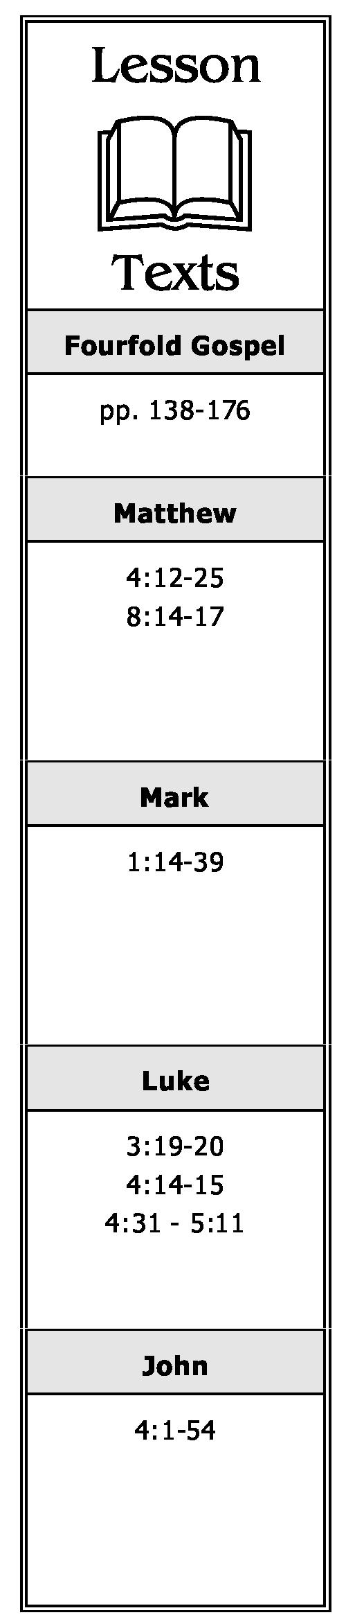
- When Jesus heard that John the Baptist had been put in prison, where did He go?
- Why had John been placed in prison?
- What had the Pharisees heard concerning the results of Jesus' preaching? Why would that be important to them? To Jesus?
- Why did Jesus go through Samaria on His way to Galilee?
- Where did Jesus have a conversation with a Samaritan woman? Briefly describe this conversation and any conclusions we should draw from it and the events surrounding it.
- What did Jesus tell His disciples His "food (KJV: meat)" was when they tried to get Him to eat?
- Although the time for harvesting the grain fields was several months away, what did Jesus say to His disciples about the "harvest?" Explain.
- Why did many of the Samaritans believe? Whose testimony was instrumental to their belief?
- What did Jesus say in reference to a prophet having honor? Why? Where was He when He made this statement?
- What did Jesus begin to preach upon His arrival in Galilee?

A Chronological Study of the Life of Jesus Gene Taylor 16

- Briefly describe the second miracle Jesus performed at Cana of Galilee. What was the first?
- While walking by the Sea of Galilee in Capernaum, who did Jesus call to follow Him? Briefly describe this incident.
Preaching in Capernaum (Matthew 4:13-16, 18-25; 8:14-17; Mark 1:16-39; Luke 4:31-44; 5:1-11)
- Whose prophecy was fulfilled when Jesus left Nazareth and went to live in Capernaum?
- What characteristic of Jesus' teaching astonished those who heard Him teach in the synagogue at Capernaum?
- After an unclean spirit in a man at Capernaum recognized Him, what confession did he make concerning Jesus? What did Jesus say to this unclean spirit? What was the reaction of the people as a result of the unclean spirit obeying Jesus?
- After leaving the synagogue in Capernaum, into whose house did Jesus go? Who did He find sick there? What did He do?
- When Simon and others came to Jesus and told Him the people were seeking Him, what reason did He give for separating Himself from the multitudes who were seeking Him?
- As Jesus traveled all over Galilee, what did He preach? What else did He do?
- Where were the multitudes from who followed Jesus as a result of the miracles and teaching He had done during His travels in Galilee?
A Chronological Study of the Life of Jesus Gene Taylor 17

